Algorithms_Data Structures

Product.cs
using System;
class Product
{
public int ProductId;
public string ProductName;
public string Category;
public Product(int id, string name, string category)
{
ProductId = id;
ProductName = name;
Category = category;
}
}

File 2: SearchOperations.cs
using System;
class SearchOperations
{
// Linear Search
public static Product LinearSearch(Product[] products, int id)
{
foreach (Product p in products)
{
if (p.ProductId == id)
return p;
}
return null;
}
// Binary Search
public static Product BinarySearch(Product[] products, int id)
{
int low = 0;
int high = products.Length - 1;
while (low <= high)
{
int mid = (low + high) / 2;
if (products[mid].ProductId == id)
return products[mid];
if (products[mid].ProductId < id)
low = mid + 1;
else
high = mid - 1;
}
return null;
}
}

File 3: Program.cs
using System;
class Program
{
static void Main(string[] args)
{
Product[] products =
{
new Product(101, "Laptop", "Electronics"),
new Product(102, "Phone", "Electronics"),
new Product(103, "Shoes", "Fashion"),
new Product(104, "Watch", "Accessories")
};
Console.WriteLine("Linear Search");
Product p1 = SearchOperations.LinearSearch(products, 103);
if (p1 != null)
Console.WriteLine($"Found: {p1.ProductName}");
else
Console.WriteLine("Product Not Found");
Console.WriteLine();
Console.WriteLine("Binary Search");
Product p2 = SearchOperations.BinarySearch(products, 104);
if (p2 != null)
Console.WriteLine($"Found: {p2.ProductName}");
else
Console.WriteLine("Product Not Found");
}
}

Output: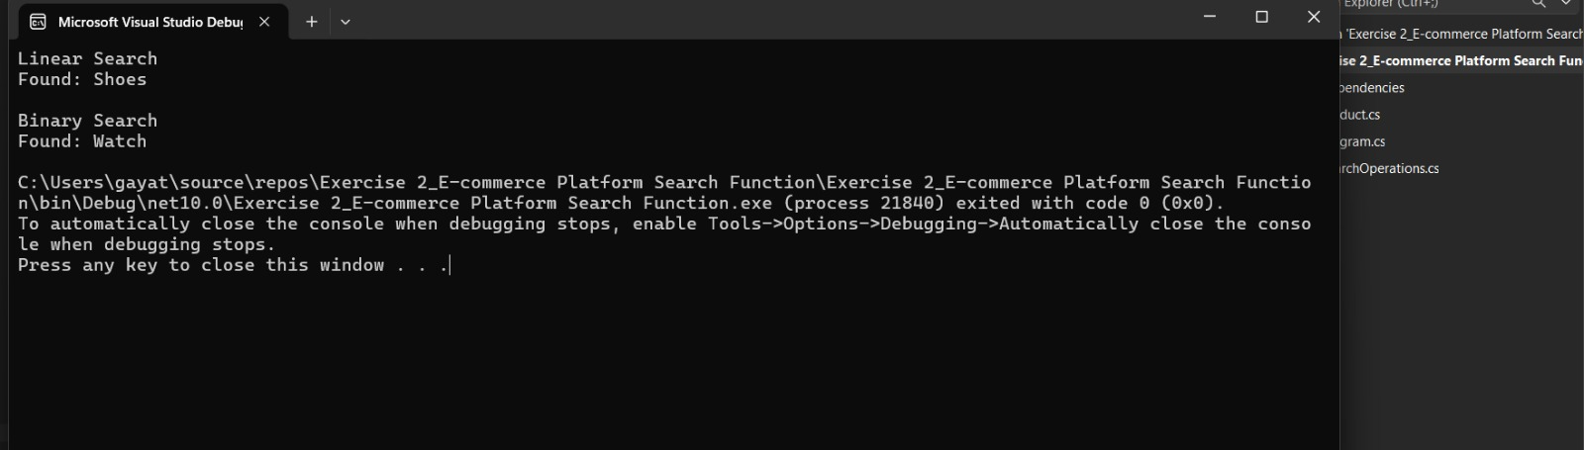

Exercise 7: Financial Forecasting

Forecast.cs
using System;
class Forecast
{
// Recursive method to calculate future value
public static double FutureValue(double currentValue, double growthRate, int years)
{
if (years == 0)
return currentValue;
return FutureValue(currentValue * (1 + growthRate), growthRate, years - 1);
}
}

Program.cs
using System;
class Program
{
static void Main(string[] args)
{
double currentValue = 10000; // Initial amount
double growthRate = 0.10; // 10% growth
int years = 5;
double futureValue = Forecast.FutureValue(currentValue, growthRate, years);
Console.WriteLine("Current Value : " + currentValue);
Console.WriteLine("Growth Rate : " + (growthRate * 100) + "%");
Console.WriteLine("Years : " + years);
Console.WriteLine("Future Value : " + futureValue);
}
}

Output:

